A4 – MQ135 Sensor
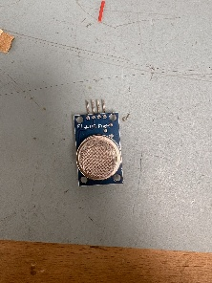
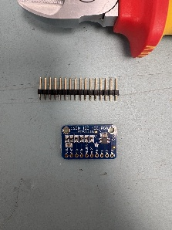
Preparation:
For this sprint, we were given one MQ135 sensor module which will measure gas in the air and one ASD1115 16-bit converter module which converts analog signals into digital data.

Installing:
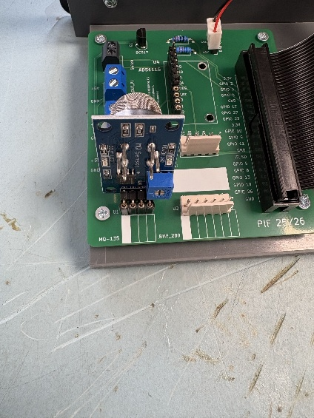
We install the MQ135 sensor module on the PCB where the female 4 pin marked MQ135 is.

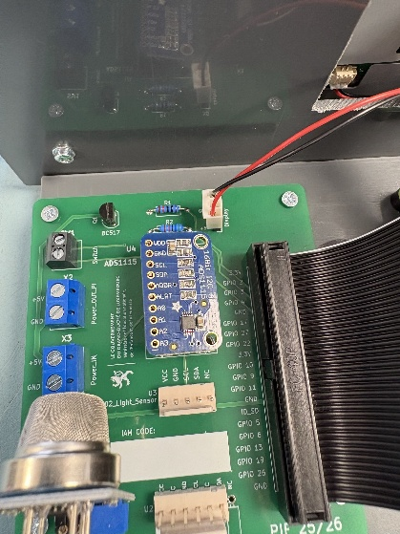
For the ADS1115 module we have to install a male 6 pin onto a female 10 pin and then solder the ADS1115 module on the male 6 pin.

